Lab Journal
Introduction
Glycosyrin is an iminosugar inhibitor of glycosidases in plants, and is produced by a biosynthesis cluster of five genes. Though it has primarily been studied in Pseudomonas syringae, glycosyrin can be produced by other bacteria, and possesses diverse functions, such as inhibiting the β-galactosidase BGAL1, which helps proteases release flg22 peptides from the Pathogen Associated Molecular Pattern (PAMP) flagellin to initiate the Pattern Triggered Immunity (PTI) response. glycosyrin has a range of other roles, such as causing the accumulation of osmolytes trehalose and galactosylglycerol, potentially enhancing water soaking. Glycosyrin also poses exciting possibilities for human health as iminosugars have been used to treat Type II diabetes and lysosomal storage disorders, so glycosyrin has been proposed as a potential target for the development of new therapies.
This experiment explored the impact of glycosyrin on the glycosylation of the apoplastic proteome as well as the specific protein Fluorescein di-β-D-galactopyranoside (FDG).
Aims of the Experiment
- To understand the general effects of glycosyrin on the glycosylation of the apoplastic proteome of Nicotiana benthamiana, specifically whether it inhibits glucosidases and galactosidases.
- For the Western blots with the lectins Ricinus communis agglutinin 1 (RCAI) and Concanavalin A (ConA), the null hypothesis was no significant difference in the level of lectin binding between the leaves infiltrated with Agrobacterium containing the empty vector control and the leaves infiltrated with Agrobacterium containing the gsn cluster. The alternative hypothesis: there will be a significant increase in the level of level of lectin binding between the control and glycosyrin treatment because glycosyrin would inhibit glycosides that would otherwise remove monosaccharides.
- We also examined the impact of glycosyrin on the specific protein expressed by Agrobacterium in the apoplast-- Fluorescein di-β-D-galactopyranoside (FDG). FDG only fluoresces when its terminal galactose residues are removed, so the null hypothesis was no significant difference in the relative levels of FDG between the controls (FDG alone and FDG infiltrated into a leaf section infiltrated three days prior with the empty vector) and the leaf section infiltrated with glycosyrin three days prior to FDG infiltration.
Materials

Inoculation
- Four 50ml falcon tubes.
- 70% ethanol for sterilisation.
- 40 ml of bacteria growth media.
- 40 μl of rifampicin.
- 8 μl of tetracycline.
- A lawn or streak plate of aNS33 Empty Vector (EV) Agrobacterium strain.
- A lawn or streak plate of aNS37 (GV301 + gsn cluster) Agrobacterium strain.
- P10 and P2 pipettes.
- Equipment: biosafety cabinet and orbital shaker.
Agroinfiltration
- 500 μl of MES pH5.6.
- 500 μl of MgCl₂.
- 5 μl of acetosyringone.
- Sterile water.
- Four 50ml falcon tubes.
- Three cuvettes.
- Nine Nicotiana benthamiana plants.
- Four needleless 1ml agroinfiltration syringes.
- A face mask.
- Masking tape.
- Tissue.
- Whiteboard pens.
- P5000, P1000, P200 and P10 pipettes.
- Centrifuge.
- Spectrophotometer.
Apoplastic Fluid Extraction
- Six falcon tubes.
- Six 20 ml syringes.
- A 50 ml syringe.
- De-ionised water.
- Tweezers.
- Tissue.
- Centrifuge.
Lectin Blot
- Seven 2ml Eppendorf tubes.
- Six 1.5 ml Eppendorf tubes.
- 600 μl of acetone.
- 15 μl of 1M NaCl.
- P10, P20, P200 and P1000 pipettes.
- Centrifuge.
- 100 μl of DTT.
- 250 μl of Laemmli buffer.
- Sterile water.
- Tris-Glycine-SDS (TGS) buffer.
- A heat block.
- A gel cassette.
- 10 μl of PageRuler Prestained Protein Ladder.
- A Phosphate Buffered Saline (PBS) tablet.
- A 1 litre bottle.
- A 1 litre measuring cylinder.
- Two PDVF membranes.
- Sterile scissors.
- Tweezers.
- Transfer buffer.
- Transfer cassette.
- Roller.
- 100% ethanol.
- Four filter paper stacks.
- 10 μl of Tween-20.
- 2 ml of 1x Carbo-Free blocking solution.
- Four 50ml falcon tubes.
- A gel shaker.
- Three petri dishes.
- Two 15 ml tubes.
- 10 μl of RCAI.
- 10 μl of ConA.
- 1.5 g of Bovine Serum Albumin (BSA).
- Mass balance and weighing boat.
- Spatula.
- 6 μl of Strepavidin-HRP.
- 1 ml of luminol dye.
- 1 ml of hydrogen peroxide.
- ImageQuant LAS400 scanner.
- Epson scanner.
- Ponceau solution.
Fluorescein di-β-D-galactopyranoside (FDG)
- Three petri dishes.
- A 2ml tube.
- 200 μl of 1M FDG.
- Sterile water.
- Three 1ml needleless agroinfiltration syringes.
- Typhoon5 biomolecular imager.

Methods
Inoculation
- Label four 50 ml falcon tubes with either EV or gsn, name and date. There should be two falcon tubes for EV and two for gsn in order to have enough bacterial culture to agroinfiltrated an entire leaf.
- The remaining steps in inoculation are carried out inside a biosafety cabinet. Surface sterilise the gloves with ethanol.
- Add 10 ml of media containing sugar, ions and amino acids to each falcon tube.
- Use a P10 pipette to add 10 μl of rifampicin to the media.
- Use a P2 pipette to add 2 μl of tetracycline to the media, pipetting into the liquid as it is a small volume. The antibiotics are added to create a selective media.
- Surface sterilise the gloves again. Once dry, bend a pipette tip, and use it to scoop up the appropriate bacteria from the plate, and drop the entire pipette tip into the tube. The bacteria for the EV tubes are taken from a plate of the aNS33 EV strain, and the bacteria for the gsn tubes are taken from a plate of the aNS37 strain, containing the gsn biosynthesis cluster. Bacteria should be added to the EV tube first to reduce risk of contamination.
- Screw on the lids of each of the falcon tubes, and place in an orbital shaker at 28°C.
Agroinfiltration
- Prepare the agroinfiltration buffer.
C1V1 = C2V2.
All stock concentrations were 1M. Final concentrations in the buffer: 10 mM MES pH5.6, 100µM acetosyringone and 10 mM MgCl₂.
MES and MgCl₂: 1000 mM x V = 10 mM x 50 ml V = 0.5 ml = 500 μl.
Acetosyringone: 1000 mM x V = 0.1 mM x 50 ml V = 0.005 ml = 5 μl.
Pipette 500 μl of MES pH5.6 (pH buffer), 500 μl of MgCl₂ (an osmolyte) and 5 μl of acetosyringone into a 50 ml falcon tube.
- Use a P1000 to fill the rest of the falcon tube with sterile water.
- Centrifuge the bacterial cultures at 4,000 rpm at room temperature for 5 minutes, ensuring the centrifuge is balanced.
- Discard the supernatants into a falcon tube for autoclaving.
- Resuspend the bacterial pellet in 2ml of agroinfiltration buffer, and mix, using a P1000 pipette. Combine the two EV bacterial cultures into a single tube, and the two gsn bacterial cultures into a single tube.
- Pipette 100 μl of bacteria suspension into a cuvette, and add 900 μl of agroinfiltration buffer. this is a 10x dilution to ensure the bacterial concentration inferred from the optical density (OD) is reliable.
- Blank the spectrophotometer first using a cuvette containing 1000 μl of agroinfiltration buffer.
- Measure the optical densities (OD) of the EV bacteria strain in one cuvette and the gsn bacteria strain in the other cuvette at 600nm with spectrophotometer.
 | OD600
Buffer | 0.000
Empty Vector | 0.567
Gsn | 0.618

- Dilute the bacterial cultures to OD = 0.5 in 50 ml falcon tubes.
C1V1 = C2V2
EV: (0.567 x 10) x V = 0.5 x 20 V = 1.764 ml.
Gsn: (0.618 x 10) x V = 0.5 x 20 V = 1.618 ml.
Fill the rest of the tube with agroinfiltration buffer up to 20 ml using a P5000.
- Select the leaves for agroinfiltration: typically, these are leaves 6 and 7, counting from the bottom up. The agroinfiltration should be carried out whilst wearing a face mask.
- Use a P200 pipette tip to make a tiny wound in the underside of the leaf to be infiltrated. It may be necessary to make several wounds, and infiltrate several areas, in order to infiltrate the whole leaf, though wounding should be minimised to ensure the plants survive.
- Use a needleless syringe to infiltrate the whole leaf for six plants, two leaves per plant. Infiltrate two whole leaves of three plants using EV bacterial cultures. Infiltrate two whole leaves of three plants using gsn bacterial cultures. These six plants will be used for the lectin blot.
- Change gloves between each culture.
- Use tissues to dry up excess cultures.
- Label the leaves that have been infiltrated using a masking tape label on the petioles of the infiltrated leaves, indicating EV or gsn.
- An additional masking tape label with the name and date should be added to the pots of the plants.
- Infiltrate a further three plants (two leaves on each) to use with the FDG probe. Infiltrate a large spot of EV on one side of each leaf and a large spot of gsn on the other side of each leaf.
- Dry the leaf with tissue, label each spot as EV or gsn (EV on the left-hand side of each leaf) with a whiteboard pen, and draw a circle on the top side of each leaf around the infiltrated area.
- Leave the agroinfiltrated plants in trays under the lights for three days.
Apoplastic Fluid Extraction
The apoplastic fluid is extracted rather than the intracellular proteins because glycosylated proteins tend to be secreted into the apoplast, and glycosyrin is produced in the apoplast by Agrobacterium (to simulate a plant pathogen) rather than transiently expressed in the plant.
- Prepare, and label, six falcon tubes: each tube should have a 20 ml syringe without a plunger inside.
- Cut off the two leaves from one of the plants.
- Rinse them in de-ionised water.
- Roll the leaves, and insert them into a 50 ml syringe without the plunger.
- Fill the syringe with de-ionised water, covering the tip with your finger.
- Push the plunger, still covering the tip, to fill the mesophyll with water to make it easier to extract the apoplastic fluid (AF) by centrifugation later.
- Use tweezers to remove the leaves, and dry them.
- Roll up the leaves, and insert them into the 20 ml syringe inside the falcon tube.
- Store the tube on ice.
- Repeat for all six plants (3 EV and 3 gsn).
- Centrifuge the tubes at 4 °C, 500x g and acceleration and deceleration of 4 for 20 minutes.
Lectin Blot
- Label six Eppendorf tubes EV1, 2 and 3 and Gsn1, 2 and 3.
- Pour out the AF from the each of the falcon tubes into six 2 ml Eppendorf tubes.
- Pipette 150 μl of AF into six 1.5 ml Eppendorf tubes, also labelled as EV1, 2 and 3 and Gsn1, 2 and 3.
- Pipette 15 μl of 1 M NaCl into the 1.5 ml Eppendorf tubes.
- Pipette 600 μl of acetone into the 1.5 ml Eppendorf tubes.
- Invert ten times to mix.
- Store the 2 ml tubes in the freezer in a larger falcon tube labelled with the date, group name and description of the contents.
- Keep the 1.5 ml tubes on ice for 15 minutes to precipitate the protein.
- Centrifuge the 1.5 ml tubes at 12,000xg for 10 minutes.
- Make the loading buffer. Add 100 μl of DTT, 250 μl of Laemmli buffer and 650 μl of sterile water. Invert to mix.
- Remove the supernatant, and air dry briefly (on ice).
- Add 30 μl of loading buffer.
- Heat the 1.5 ml Eppendorf tubes on a heat block at 95 °C for five minutes. Store them on ice.
- Add TGS buffer to the gel cassette.
- Use a P1000 to flush the gel with TGS buffer.
- Pipette 10 μl of ladder into the first well, then 10 μl of EV 1, 2 and 3 into wells 2, 3 and 4, skip well 5 and then 10 μl of gsn 1, 2 and 3 into wells 6, 7 and 8 and PageRuler Prestained Protein Ladder into well 9. Repeat this for a second gel.
- Run the gel at a slower speed (50 mA) for the first ten minutes to squeeze the proteins into a thinner layer for better resolution, then increase the speed to 190V until the proteins reach the end of the gel.
- Make Phosphate Buffered Saline (PBS) buffer by dissolving a PBS tablet in 1 litre of water in a bottle, adding the water using a 1 litre measuring cylinder.
- Transfer to the PDVF membranes:
  - Use sterile scissors to cut the membranes to size.
  - Use tweezers to dip the filter paper stack in transfer buffer, let it drain, so it doesn't create a pool in the transfer cassette. Roll out any bubbles.
  - Use tweezers to dip the membrane in pure ethanol to activate it, so it can conduct electricity, then put the membrane on top of the filter paper.
  - Use your hands to lift the gel on top of the membrane, and roll with the roller dipped in transfer buffer.
  - Use tweezers to add another filter paper stack dipped in transfer buffer.
  - Roll gently. Repeat this for the other gel.
  - Run the current for 10 minutes.
- Make the blocking buffer: add 2ml (using a P1000 pipette) of 1x CarboFree blocking solution, and 10 μl (using a P10 pipette on the surface of the Tween-20) of Tween-20 into a falcon tube. Add sterile water up to the 20 ml mark using a P1000.
- Add the membrane to the blocking buffer in a petri dish. Place on the orbital shaker for 30 minutes. A blocking buffer is used, so that the lectin only binds to glycosylated proteins.
- Remove the carbo-free blocking buffer by decanting it into a falcon tube.
- Use tweezers (plastic) to transfer each membrane into a petri dish-- one labelled RCAI for Ricinus communis agglutinin 1 and one labelled ConA for Concanavalin A.
- Add 10 ml of PBS to two 15 ml tubes. Add 10 μl of RCAI to one of the tubes of PBS and 10 μl of ConA to the other tube. Invert the tubes to mix.
- Pour the tubes into each corresponding petri dish.
- Place the petri dishes in an orbital shaker in a cold room overnight.
- Discard the RCAI and ConA.
- Rinse with PBS-Tween-20 (PBS-T): add PBS to cover the membrane, shake by hand and discard the PBS-T. Wash with PBS-T for seven minutes then five minutes then five minutes on a gel shaker to remove unbound lectin.
- Discard the PBS-T. Add 1.5 g of BSA (bovine serum albumin) to 30 ml of PBS-T in a 50 falcon tube-- this is for blocking.
- Add 6 μl of Strepavidin-HRP to the 30 ml of BSA + PBS-T. RCAI is a biotinylated lectin, so the Strepavidin antibody binds to the lectin as it is specific to biotin.
- Cover the membranes in the Strep-HRP + BSA + PBS-T solution, and place them on the gel shaker for 30 minutes.
- Discard the solution. Wash with PBS-T: do one rinse with PBS-T, then wash with PBS-T on the gel shaker for seven minutes, five minutes then five minutes.
- Add 1 ml of luminol dye and 1 ml of hydrogen peroxide in a 2ml tube. Invert to mix. Store the tube in the dark.
- Detect chemiluminescence using an ImageQuant LAS400 scanner. Wait for the scanner to cool to -35 °C. Add 1ml of the luminol-hydrogen peroxide mixture to each membrane. Place the membrane in the scanner. Settings: auto exposure, precision exposure type, exposure time of six seconds and standard resolution/sensitivity.
- Rinse the membranes in sterile water. Cover the membranes in Ponceau solution, and leave to stain until distinct red bands appear.
- Scan the membranes in-between two sheets of plastic using an Epson scanner, pushing out any air bubbles.

Fluorescein di-β-D-galactopyranoside (FDG)
- Cut the leaves, and place them on petri dishes.
- Dilute the 1M FDG ten-fold: add 200 μl into a 2ml tube, and fill the rest with sterile water, so the concentration of FDG is 100 mM FDG.
- Agroinfiltrate a smaller spot of FDG within each spot of EV and gsn on each leaf using a 1ml syringe.
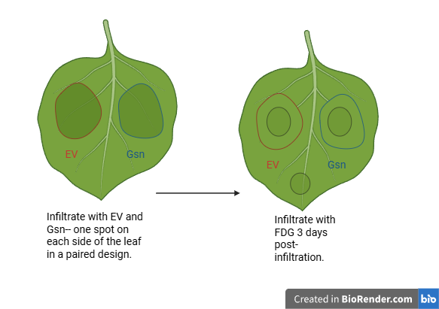
- Infiltrate FDG in an additional spot on the leaf that had not previously been infiltrated. All spots should be approximately the same size.
- Place the leaves on the Typhoon5 biomolecular imager. Add the glass covering on top, and close the scanner.
- Use 488 nm wavelength because this is the wavelength required for fluorescein (the fluorescent group of FDG) to fluoresce. Each pixel is 100 nm.
Results
FDG
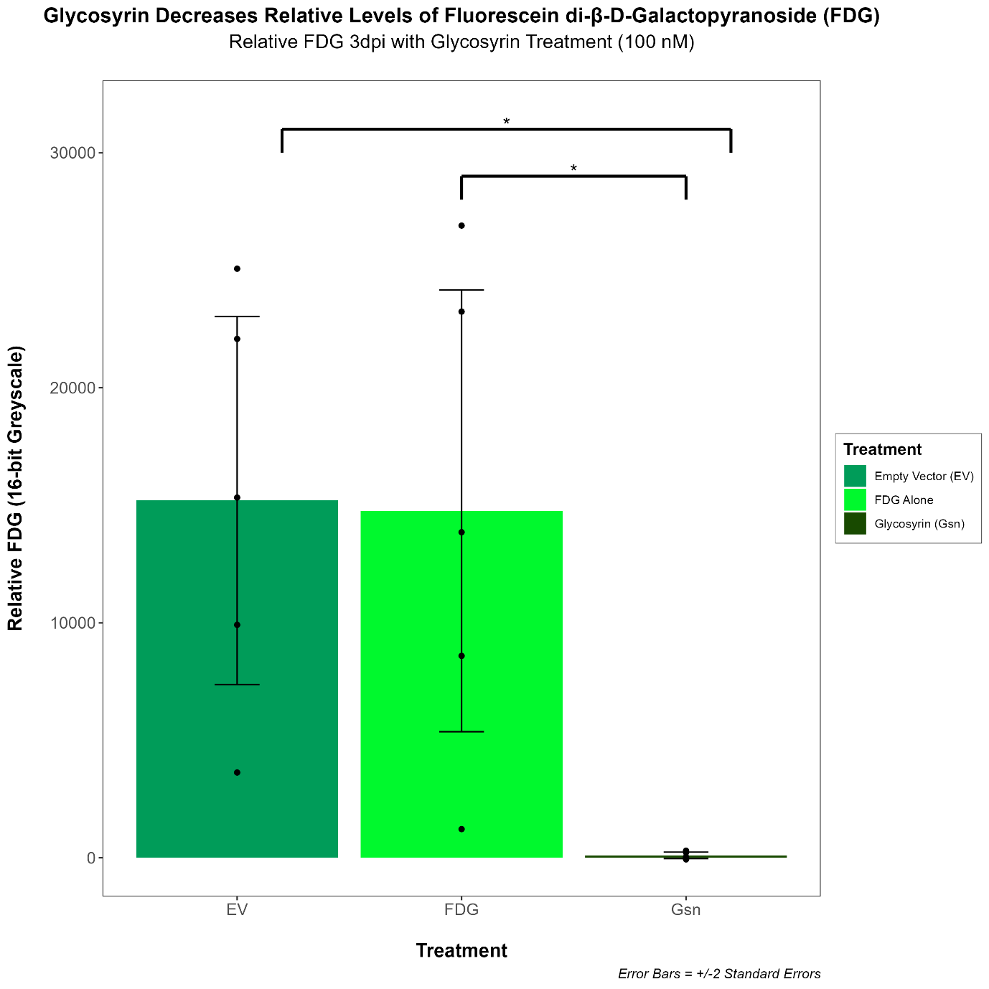
Fig. 1: Relative FDG 3 dpi with glycosyrin treatment.

Group | Standard Deviation | Sample Size | Standard Error | Mean
EV | 8753.107 | 5 | 3914.50824 | 15201.5166
FDG | 10504.516 | 5 | 4697.76220 | 14760.3824
Gsn | 153.754 | 5 | 68.76086 | 103.8288

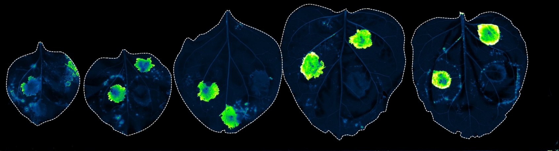
Fig. 2: summary statistics for the relative levels of FDG in different leaf sections.
Gsn
Gsn
Gsn
Gsn
Gsn
EV
EV
EV
EV
EV
FDG

FDG

FDG

FDG

FDG

Typhoon Scans
Fig. 3: fluorescence due to cleavage of FDG in the absence of glycosyrin.
Each of five leaves was infiltrated with a section of Agrobacterium containing the empty vector and a section of Agrobacterium with the Gsn biosynthesis cluster either side of the mid-vein. This paired design reduced extraneous variation between leaves. Three days post-infiltration, each of the sections was infiltrated with Agrobacterium containing FDG as well as an additional spot of FDG on an area of each leaf that had not previously been infiltrated (as a positive control). The leaves were scanned using a Typhoon scanner at 488nm wavelength. When scanned under the 635 nm wavelength, no fluorescence (just the puncture wounds on the leaf) was observed as this was not the wavelength appropriate for the FDG. The level of fluorescence was measured using ImageJ.
Before conducting an ANOVA and pairwise t-tests, I subtracted the background fluorescence from every measurement of mean fluorescence, and then confirmed the data conformed to the assumptions of normality and homoscedasticity. To check the data was normal, I carried out a Shapiro-Wilk test for each of the groups (empty vector, FDG alone and glycosyrin). All the p-values were above 0.05, indicating the data were not significantly non-normal. To check for homoscedasticity of variance, I carried out a bartlett test. The p-value was less than 0.05, indicating significantly unequal variances. However, the sample sizes were all equal, so the test should still be robust to these differences in variances, and the sample sizes were small, so it was appropriate to still use pooled standard deviation in the pairwise t-test.
I conducted an ANOVA with the explanatory variable Group (with levels empty vector, FDG alone and glycosyrin), and the p-value was 0.01625, which is less than 0.05, so at least one of the groups had significantly different levels of FDG. When the plant from which the samples were taken was added as an additional explanatory variable in the ANOVA, R^2 = 0.8311, compared to R^2 = 0.4967, when the treatment group was the only explanatory variable in the model.
To identify the groups between which the levels of FDG were significantly different, I conducted pairwise t tests: the p-value between FDG and empty vector was 0.931, which is non-significant at the 5% significance level. The p-values between glycosyrin and FDG and glycosyrin and empty vector were both 0.032, which is less than 0.05, indicating that there are significant decreases in the relative levels of FDG between the FDG alone control and glycosyrin and the empty vector control and glycosyrin.
Western Blotting
For the ConA lectin blot, I started by adjusting for background signal (I adjusted for background signal for all measurements of both lectin blots by subtracting the area measurement of lane 5). Visual inspection of the ConA blot suggests glycosyrin tends to affect the glycosylation of higher molecular weight proteins more as the band intensity is higher for proteins that travelled shorter distances on the gel, so I measured proteins with a molecular weight 30kDa or higher (by comparing to the protein ladder). To ensure the assumptions for a two-sample t-test were met, I performed a Shapiro-Wilk test of normality on each of the samples: p-value = 0.2455 for the empty vector control, and p-value = 0.9803 for glycosyrin, so the samples were not significantly non-normal. I also conducted a F-test to ensure the variances were equal: p-value = 0.5899 and F = 0.41837, so there was not a significant difference in variances between the control and glycosyrin samples. Hence, the data met the assumption of the two-sample t-test. The results of the two-sample t-test were t = -8.8253, df = 4, p-value = 0.0009098, so there was a significant different in the levels of ConA binding between the control and the glycosyrin-treated leaves.
After adjusting for the background signal, I performed a Shapiro-Wilk test on each of the samples for RCAI (empty vector and glycosyrin). The p-values were 0.3907 and 0.3318, respectively, so the data was not significantly non-normal. I then conducted a F test to determine whether the samples had equal variance. F = 0.01527 and p-value = 0.03008. the variances were not equal, so I used Welch's two-sample t-test, from which I obtained t = -1.6853 and the p-value = 0.2303. This suggested the difference in RCAI lectin binding was not significantly different between the control and glycosyrin-treated leaves. This result compared the entire lanes, so I also performed the t-test using minimum 25kDa molecular weight proteins as the signal appeared somewhat stronger at higher molecular weights (albeit not to the same extent as with ConA) upon visual inspection. All the assumptions of a two-sample t-test were met: the p-values for the Shapiro-Wilk tests were p-value = 0.7768 for the control and p-value = 0.3433 for glycosyrin, and for the F test F = 0.033359 and the p-value = 0.06456. ergo, the variances were not significantly unequal and the sample distributions were not significantly non-normal. However, there was still not a significant difference in the levels of RCAI binding as t = -1.7861 and p-value = 0.1486. When I used a threshold of 50kDa, the assumptions were also still met (for normality, p= 0.9139 for the empty vector and p = 0.1921 for glycosyrin, and for the F-test, F = 0.16225 and p-value = 0.2792), and the difference was still non-significant, though the p-value was lower: t = -2.4768 and p-value = 0.06845.
To ensure the levels of protein loaded into the empty vector lanes and the glycosyrin lanes were equal, I performed a two-sample t-test on the intensity of the bands in the Ponceau gel, comparing the empty vector and glycosyrin groups (for both the RCAI and ConA gels separately). I selected a two-sample t-test because there are only two groups, and every sample came from a different plant, so samples are independent and unpaired. First, I subtracted the background signal from each of the measurements of intensity of the samples. I then performed a f-test to check for the homogeneity of variances: the F values were 1.3495 for RCAI and 2.2813 for ConA, and the p-values (0.8513 for RCAI and 0.6095 for ConA) exceeded 0.05, indicating no significant difference in variance between the glycosyrin and empty vector groups for either of the lectin blots. The p-values for the Shapiro-Wilk tests of each group for RCAI were 0.5915 for the empty vector and 0.1931 for glycosyrin, both of which are greater than 0.05, so the data was not significantly non-normal. The p-values for the Shapiro-Wilk test for ConA were 0.6687 for the empty vector and 0.9015 for glycosyrin, so both were greater than 0.05, and neither sample was significantly non-normal. Ergo, the assumptions of the two-sample t test were met for both Ponceau gels.
The t-value of the t-test for RCAI was 2.7923, and the p-value of the t-test was 0.0492 for RCAI, which is just slightly less than 0.05 (significant difference in the level of protein loading), however, this result is not particularly concerning as 0.05 is an arbitrary threshold, and this result could be due to the small puncture in the gel. Indeed, I also measured the intensity of the bands for three rows in the RCAI Ponceau. Theses rows were spread throughout the gel, and avoided the puncture wound. The p-value for row 1 was 0.366, for row 2, it was 0.4854 and for row 3, it was 0.5562. For all three of the rows, there was no significant difference between the levels of protein loaded for EV and Gsn lanes, which suggests that the puncture wound was a potential confounder. For ConA, the t value was 0.2893 and p-value of the t-test was 0.7867, which indicates there was no significant difference in the level of protein loading between the empty vector and glycosyrin lanes.
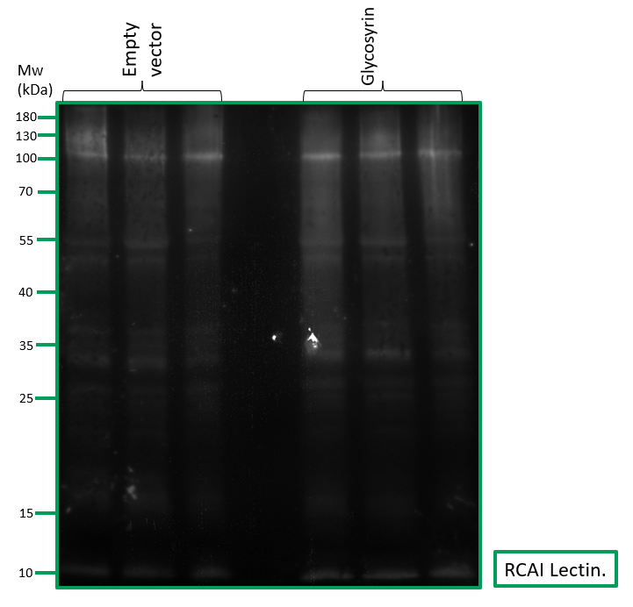
Fig. 4: RCAI Lectin Blot.

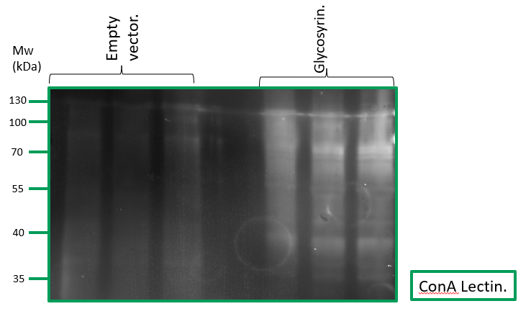
Fig. 5: ConA Lectin Blot.
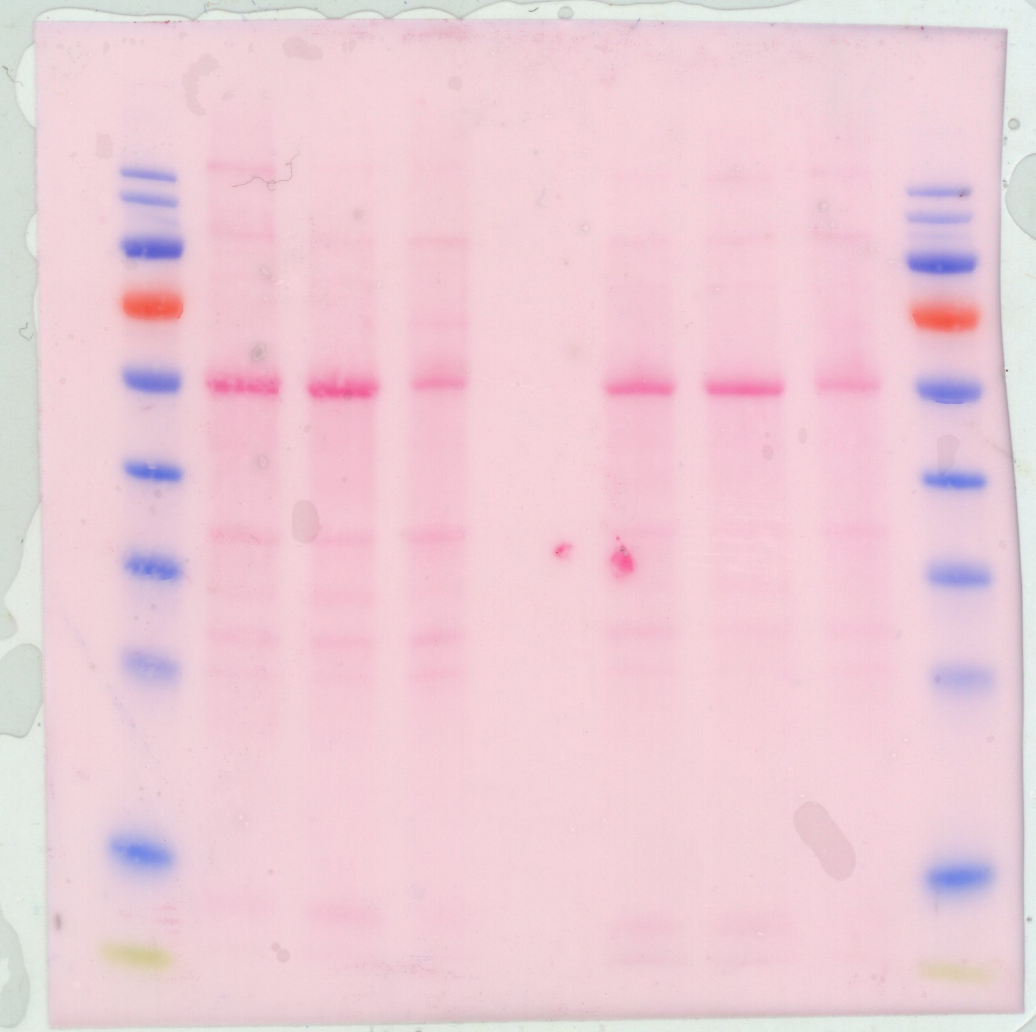
Fig. 6: The RCAI Ponceau. Empty vector on the left. Glycosyrin on the right. From top to bottom the arrows indicate rows 1-3.
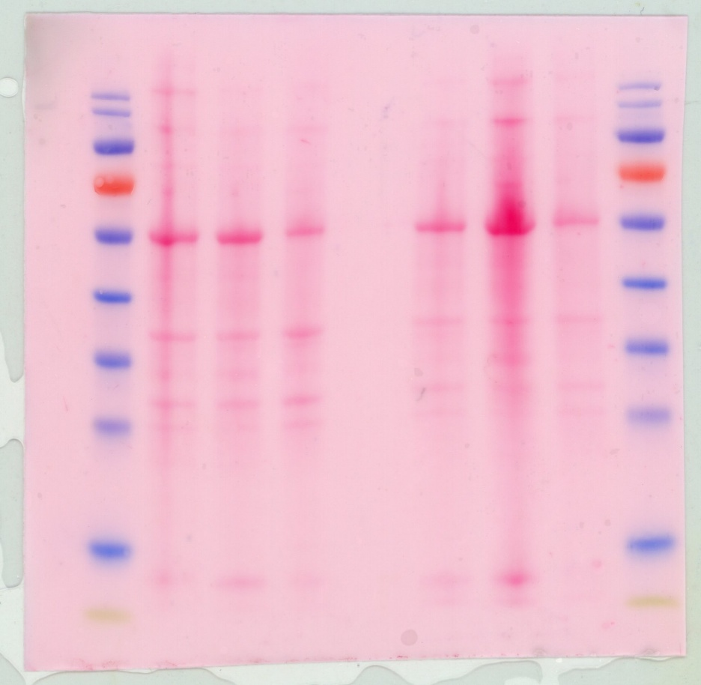
Fig. 7: ConA Ponceau. Empty vector on the left. Glycosyrin on the right.
Discussion
The negative control is the leaf halves infiltrated with EV followed by FDG. The negative control is expected to fluoresce much more than the leaf halves infiltrated with glycosyrin as glycosyrin inhibits galactosidases, thereby preventing cleavage of the galactose residues of FDG. The positive control is a small spot of FDG in an area of each leaf that has not yet been infiltrated, which is expected to have equal levels of fluorescence as the empty vector.
Fluorescence, and hence relative levels of FDG, were significantly higher in the empty vector and FDG alone controls than with glycosyrin treatment because glycosyrin inhibits galactosidases, such as BGAL1, which cleave off the galactose residues from FDG. FDG only fluoresces when the galactose residues are cleaved off as this releases its fluorescent group (fluorescein), hence levels of FDG are significantly lower with glycosyrin treatment than the controls. This represents how glycosyrin inhibits galactosidases in the apoplast as FDG is produced by Agrobacterium in the apoplast, rather than transiently expressed by the plant.
As evident in the graph, there is lots of variation between within each group, hence significantly unequal variances in the bartlett’s test. I believe the majority of this can be attributed to differences between plants as when the plant from which each sample was taken was added as an explanatory variable in the ANOVA linear model alongside the treatment groups, over 80% of the variation between samples in fluorescence was explained (as R^2 = 0.8311). The different sizes of the plants, different ages of the leaves and damage to the leaves are all confounding factors that could generate variation between samples. Damage to the leaf due to wounding in agroinfiltration could also play a role in producing variation between samples.
The relative levels of FDG reveal glycosyrin’s role in galactosidase inhibition, but FDG is only a single protein, hence we conducted two lectin blots using a mannose- and glucose-binding lectin (ConA) and a galactose-binding lectin (RCAI) to investigate the broader effects of glycosyrin on the apoplastic proteome. There was not a significant difference in the level of RCAI binding between the control and the glycosyrin samples, so we failed to reject the null hypothesis. This could be due to differences in protein loading, or damage to the leaves, so fewer proteins were produced, which would result in a weaker signal. However, the p-value was increasingly lower when higher molecular weight proteins were considered, perhaps indicating a biologically significant difference, even if it were not statistically significant. I would suggest replicating the experiment, but using larger sample sizes, e.g., three leaves instead of two per sample, and more plants, which would provide a greater statistical power to detect the difference in RCAI binding. RCAI is specific to galactose residues, and the results from the FDG experiment indicates that glycosyrin is capable of inhibiting galactosidases, so this (coupled with the lower p-values for higher molecular weight proteins) could perhaps imply that glycosyrin targets specific galactosidases, or a subset of galactosidases. This could be an interesting avenue for future research because understanding why glycosyrin targets some galactosidases, but not others, could be useful in designing a decoy enzyme to inhibit glycosyrin. For the ConA lectin blot, I considered proteins above 50kDa because there was a clear, visible difference in the level of lectin binding between the empty vector control and glycosyrin, and the p-value was 0.0009098, so the difference in ConA binding was significant at the 0.1% level. ConA is specific to mannose and glucose, so this means glycosyrin inhibits either one or both of glucosidases and mannosidases because the glucose and/or mannose residues were not removed from the apoplastic proteins. This presents clear pathways for future research, namely using more specific lectins to distinguish between the impact of glycosyrin on mannosidases and glucosidases, and investigating glycosyrin’s effect on specific proteins, particularly those of a higher molecular weight.
Regarding limitations, one of the leaves of plant three was damaged, so we used five leaves instead of six for the Typhoon scanning. With more plants and more time, we would have replicated the full experiment to ensure the results were reproducible, and used more biological replicates.
Conclusion
If permitted more time, we would have tested the lectin Galanthus nivalis lectin (Gnl), which is specific to mannose, whereas ConA binds to both mannose and glucose. This would demonstrate whether glycosyrin can enter the cell, or whether it is restricted to the apoplast, because mannosidases are found exclusively inside the cell as their primary role is in cleaving the high mannose tree in the ER, whilst glucosidases are found in the apoplast, hence testing with ConA is limited. I believe it is likely that glycosyrin enters the cell as GsnE encodes an MSF family transporter, but understanding exactly how glycosyrin crosses the cell membrane, if indeed it does, is crucial as the impact of glycosyrin could be reduced by blocking its mechanism of entry, if transporter proteins are used.
Research thus far has focussed on the effect of glycosyrin on BGAL1 in N. benthamiana. Pseudomonas syringae also varies its glycans on flagellin to evade BGAL1, which is specific to terminal modified Viosamine, so perhaps variation in glycosylation of PAMPs and iminosugar production are correlated as plant glycosidases present a strong selection pressure. Thus, I would first suggest investigating this correlation in different pathogens, beyond Pseudomonas syringae. Furthermore, Schroeder, F (2025) asserts that similar inhibitors of glycosidases could be produced by human-infecting pathogens, so if this correlation holds, I would recommend examining the genomes of pathogens that also vary their glycans to evade the human immune system for clusters similar to the Gsn cluster.
Further investigation beyond this model system is also required to understand how glycosyrin affects the glycosylation of the apoplastic proteomes in other plant-pathogen systems as glycosyrin is produced by Psuedomonas syringae strains affecting a variety of plants, such as almonds and beans, and homologous Gsn clusters are found in other plant pathogens, such as Erwinia.
The broad range of roles of glycosyrin in pathology and evading the plant immune system means that inhibition of glycosyrin and similar iminosugars could be revolutionary for engineering plant immunity. The similarity of glycosyrin to monosaccharides renders inhibition of enzymes by glycosyrin difficult to avoid, but perhaps a decoy enzyme could be developed with an increased affinity for glycosyrin relative to BGAL1 could be designed, and expressed in plants.
In conclusion, the relative levels of FDG were significantly higher in the control and FDG alone compared to glycosyrin-treated leaves, indicating that glycosyrin inhibits at least certain galactosidases. There was no significant difference between galactose-specific RCAI binding between the control and glycosyrin, so perhaps the sample sizes were insufficient, or glycosyrin only targets specific galactosidases. There was significantly higher mannose- and glucose-specific ConA binding to the apoplastic proteome extracts in glycosyrin-treated leaves compared to the control, indicating that glycosyrin inhibits mannosidases and/or glucosidases. Therefore, glycosyrin is able to transform the glycosylation of the apoplastic proteome, which is vital to understand from a plant immunity perspective. There remain many unanswered questions, such as the whether glycosyrin impacts the intracellular proteome, and whether glycosyrin impacts the proteomes of different plants in different ways. Navigating these pathways for future research is imperative in order to map the diverse roles of glycosyrin across various plant-pathogen systems.

